**III. The Third case: φd(σ) ≠ 0 and I(σ) is asymmetric.**

In this case, the distribution of *I*(*σ*) is asymmetric and there is a dispersion phase *ϕd*(*σ*). The *ϕd*(*σ*) is produced by an cand thickness T, *ϕd*(*σ*) is given by



Assume that T is 1μm. Then



So,



Different φd(σ) is considered by assigning different values to the parameters.

1. **b0 = 35, b1 = -10**μm **and φd(σ) = -4π(35-10σ)σ;**

**(1.a) Effect of φd(σ)**

According to the expression of φd(σ), then



The distribution of intensity and phase of *F(σ)* as shown in Fig.1(a) and Fig.1(b), respectively. The IFT(Inverse Fourier transform) of *F(σ)* as shown in Fig.1(c) and Fig.1(d). The unwrapped phase of *SC(z)*, as shown in Fig.1(e), it is found that the phase is nonlinear. The relevant parameters of *F(σ)* and simulation results of *SC(z)* are shown in Table 1 and Table 2.

Table 1. The relevant parameters of *F(σ)* and *SC(z).*

|  |  |  |  |  |
| --- | --- | --- | --- | --- |
| σA | zo | λA | b0 | b1 |
| 1.5510μm-1 | 10μm | 0.6447μm | 35 | -10 |

Table 2. Simulation results shown in Figs.4 (c) and (d).

|  |  |  |  |  |  |
| --- | --- | --- | --- | --- | --- |
| za | zp | za-zo | zp-zo | P | zp-za |
| 15.8174μm | 15.9786μm | 5.8174μm | 5.9786μm | 0.3433μm | 0.1612μm |

The interference signal in wavenumber domain is generated in the region from 0 μm-1 to 4 μm-1 where the weighted average wavenumber *σA* is 1.5510 μm-1, and the sampling interval *∆σ* and the sampling number are 0.0038 μm-1 and 1024, respectively. The amplitude of F(σ)is completely zero outside this region. The range of σ in *F(σ)* is consistent with the second case. The phase of F(σ) as shown in Fig.1(b) in which the value zo is 10 μm and phase φ(σ) = -4π(45-10σ)σ. After IFT(Inverse Fourier transform), we can get the position *za*of the maximum amplitude of *SC(z)* and the position zp of zero phase of *SC(z)* nearest to the position of maximum amplitude.

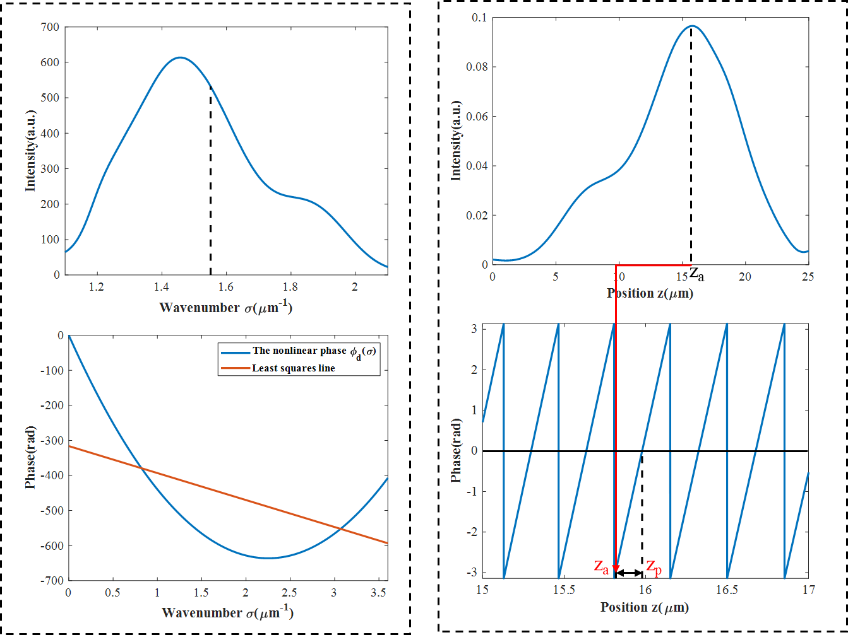

φ(σ)

(d)

(~~c~~ b)

(~~b~~ c)

(a)



Unwrapped phase

(e)

unwrap

[In Fig.(b), the rage of σ must be almost equal to the rage of σ in Fig.(a). The least square line is not necessary.]

[What is the purpose of Fig.(e)? Which value is calculated from Fig.(e)?]

Fig. 1 IFT (Inverse Fourier transform) of *F(σ)*. (a) The intensity of *F(σ)*. (b) The phase of *F(σ)*.

(c) The intensity of *SC(z)*. (d)The phase of *SC(z).* (e) The unwrap phase of *SC(z).*

**Discussion1: How does the dispersion phase *ϕd*(*σ*) influence za?**

The linear term b­­­­0σ­­ of the phase function φd(σ) will produce a linear change in the position of za and zp, but the quadratic term will produce a nonlinear change in za and zp.

**(1.b) Elimination of effect of φd(σ) by using** **a least square line for phase distribution φ(σ) of F(σ).**

The phase distribution φd(σ) will affect the measurement results, but the phase distribution φd(σ) can be eliminated by a least square line.  
**Discussion2: Why the phase distribution φd(σ) can be eliminated by a least squares line?**

It can be seen from (1.a) that the phase distribution φd(σ) is unpredictable for changes in the position za and zp, but we can make the phase distribution φd(σ) change linearly to za and zp through a least squares line. By measuring the values of za and zp and the linear relationship between za, zp and zo , the value of position zo is indirectly measured. So, the phase distribution φd (σ) can be eliminated by a least squares line. In other word, the dispersion phase distribution φd(σ) has no influence on the measurement accuracy by using a least squares line.

Denoting the least squares line in the phase distribution φ(σ) by a0+(a1-4πz0)σ, so

the spectral distribution is obtained as



So,





From formulas (6) and (7), the value of z0 can finally be obtained. The above simulation process is shown in Figure 2. The distribution of intensity I(σ) and phase a0+(a1-4πz0)σ as shown in Fig.2(a) and Fig.2(b), respectively. The IFT(Inverse Fourier transform) of *F(σ)* as shown in Fig.2(c) and Fig.2(d). Fig.2(e) and Fig.3(f) are respectively the unwrap phase of SC(z) and the nonlinear component of unwrap phase(Fig.2(e) - least square line of Fig.2(e)).

Now, We can get the least squares line a0+(a1-4πz0)σ of the phase distribution φ(σ) in which a0 is 48.6184 rad∙μm and a1­ is -316.1931 rad∙μm. Limit the value of a0 in the phase a­0+(a1-4πz0)σ to within -π to π. Through formulas (6) and (7), make the following calculations:



By performing inverse Fourier transform on the data *F(σ)*, we can get the value za is 6.1266 μm and the value zp is 6.2325 μm. The ~~errors~~ differences between the theoretical values of za and zp and the actual values in the simulation are 0.0025 μm and 0.1147 μm, respectively. The relevant parameters of *F(σ)* are shown in Table 3.The simulation results obtained from Fig.2(c) and Fig.2(d) are shown in Table 4.

[Why are the differences in za and zp between the theoretical values and the actual values so large? Maybe the reason is that the range of σ in the phase distribution of Fig.2(b) is not good.]

Table 3. The relevant parameters of *F(σ)* and *SC(z).*

|  |  |  |  |  |
| --- | --- | --- | --- | --- |
| σA | zO | λA | a1 | a0 |
| 1.5510μm-1 | 10μm | 0.6447μm | 48.6184 rad∙μm | -316.1931 rad∙μm |

Table 4. Simulation results shown in Figs.4 (c) and (d).

|  |  |  |  |  |  |
| --- | --- | --- | --- | --- | --- |
| za | zp | za-zo | zp-zo | P | P-λA/2 |
| 6.1266μm | 6.2325μm | -3.8734μm | -3.7700μm | 0.333μm | 0.0106μm |

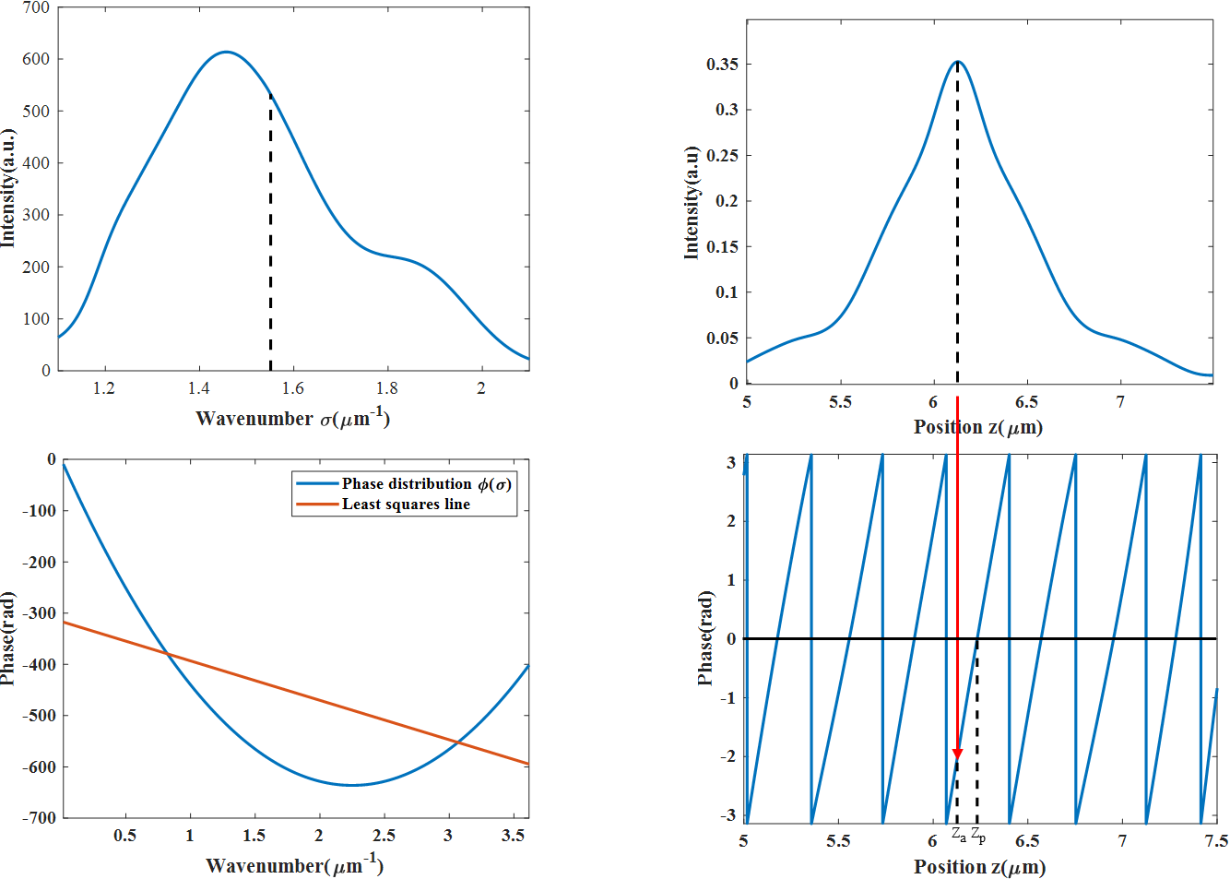

The nonlinear component of unwrap phase

（d）

（c）

（b）

（a）



（f）

（e）

Unwrap

[ Amplitude I(σ) has values in the region of σ from 1.1 to 2.1 in FIg.2(a). So the phase must be considered in this region. But, in Fig.2(b) the region of σ is very large. Please change the region of phase to the same region as the amplitude, and obtain the least squares line a0+(a1-4πz0)σ.]

[Please understand the below thing: Amplitude and phase make a vector given by Eq.(5). Phase of this vector can be defined when the amplitude is not zero.]

[What is the purpose of showing Figs. 2(e) and (f)? In this section of (1.b), the purpose is that we try to get the same values of za and zp in the theoretical values and the actual values. So please write sentences and figures by focusing on the purpose of each section.]

Fig. 2 IFT (Inverse Fourier transform) of *F(σ)*. (a) The intensity of *F(σ)*. (b) The phase of *F(σ)* afterthe least squares method.(c) The intensity of *SC(z)*. (d)The phase of *SC(z).* (e) The unwrap phase of *SC(z).* (f) The nonlinear component of unwrap phase(Fig.2(e) - least square line of Fig.2(e))

[Sorry that I made a mistake. I wrote the above sentences about the region of σ in the figures you showed in the file. Actually it is important how to make the distribution φ(σ)=φd(σ)-4πzoσ in FFT, and how to obtain the least squares line a0+(a1-4πz0)σ.

There is no noise in simulations, the data of Eq. (4) for FFT is made in the region from σ=0 to σmax. The data of FFT are I(σ)cos(φ(σ)) and I(σ)sin(φ(σ)). Hence the phase distribution does not exist when I(σ) is almost zero.

The least squares line should be calculated in the region where I(σ) is not almost zero. Since I have not actually calculated the least squares line by Matlab, please ask Ji or Teacher Luo about the region of σ for the least squares line. This region is determined by the values of I(σ). ]